Object 1 :

CAR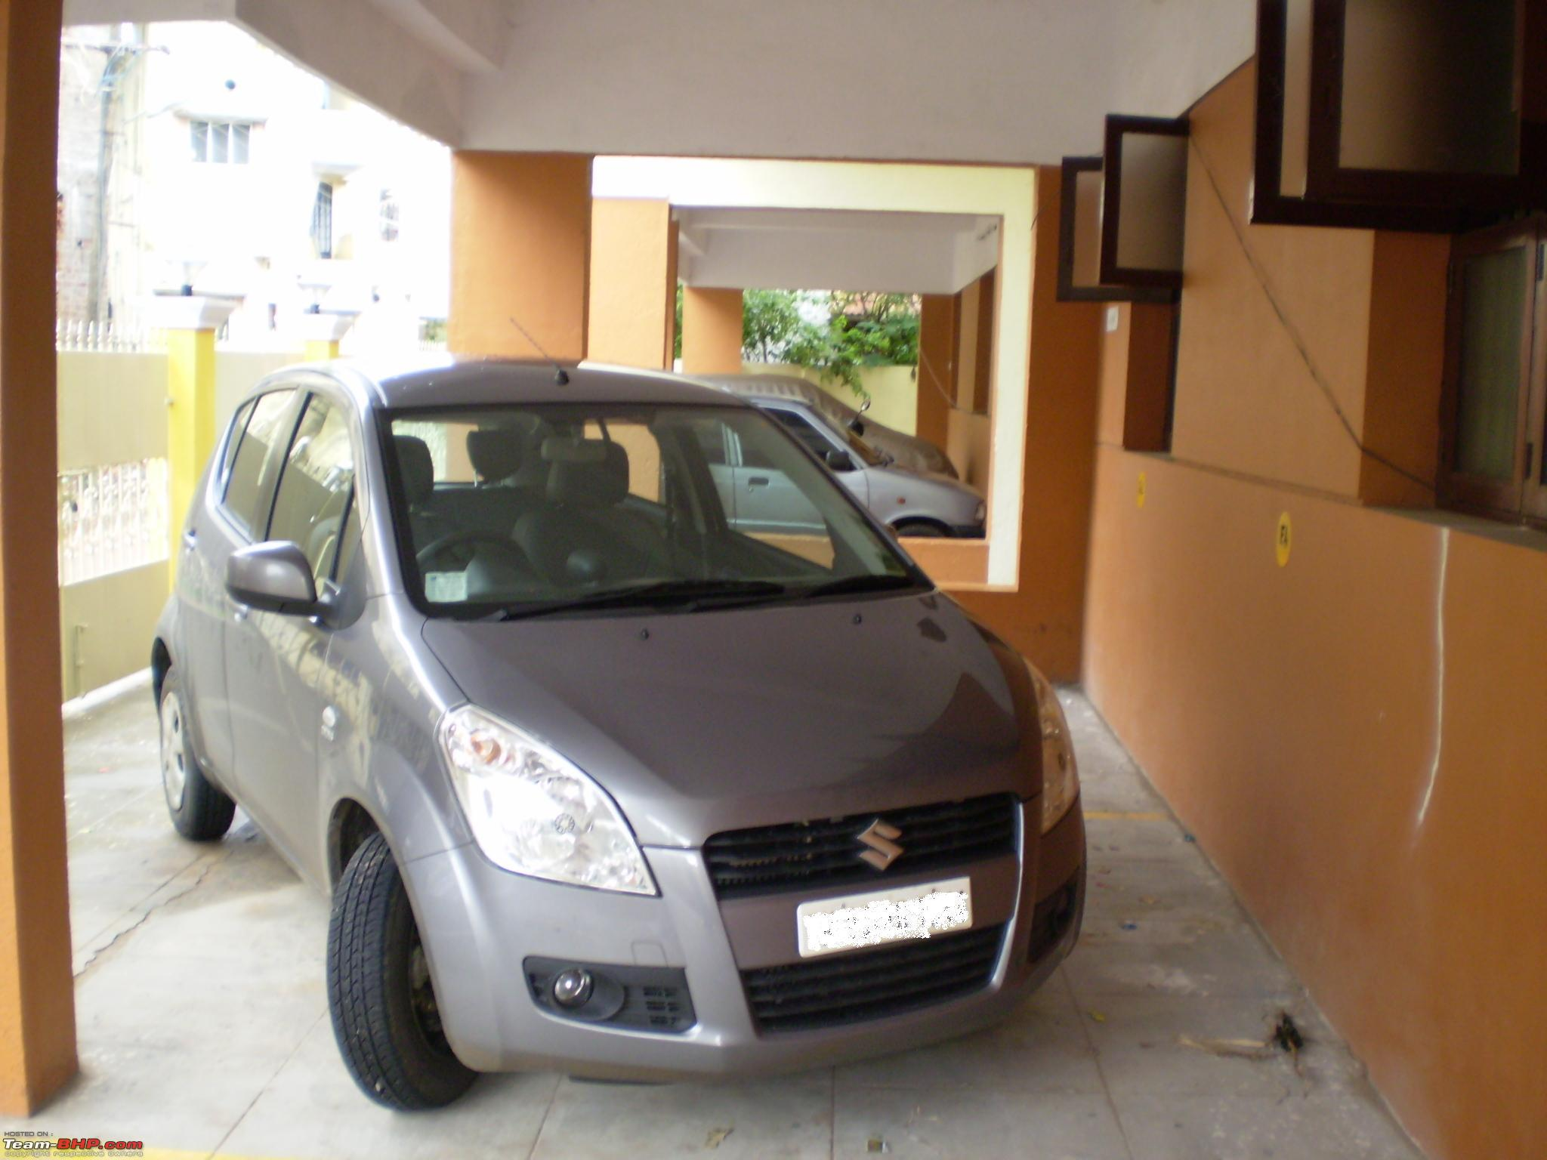

Properties : Color , Gear(Auto Gear) , Brand, no. of seaters , Speed

Behaviour : Travel from A to B , Acts as shed(Closed Environment)

Behaviour changing property - No. of passengers→ changes top speed

Object2:

Microwave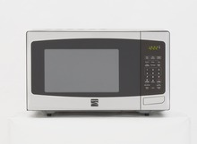

Properties : Color , Heating things , Brand, functions(Bake,cook etc)

Behaviour : Temperature change , Changing Time

Behaviour Changing Time → changes temperature it heat the other object